**F.A. (By Sir Farhan) Evening (Final year - 2013)**

***Q1#)*** A list of accounts for Maple Inc. at December 31, 2010, follows:

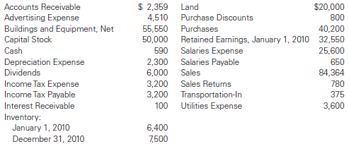

Required:

1. Determine Cost of Goods Sold (COGS) for December 31, 2010.
2. Determine Net Income for December 31, 2010.
3. Prepare a balance sheet dated December 31, 2010.

#Solution#

COGS:

**\*Beginning inventory: 6,400**

|  |  |
| --- | --- |
| Purchases | + 40,200 |
| Purchase Discounts | - 800 |
| Transportation-In | + 375 |

**\*Net Purchase: 39,775**

**\*Ending Inventory: 7,500**

COGS = Beginning Inventory + Net Purchase – Ending Inventory

COGS = 6,400 + 39,775 – 7,500

**\*COGS = 38,675**

Net-Income:

|  |  |
| --- | --- |
| Advertising Expense | 4,510 |
| Depreciation Expense | 2,300 |
| Salaries Expense | 25,600 |
| Utilities Expense | 3,600 |
| Income-Tax Expense | 3,200 |

**\*Total Expense: 39,210**

|  |  |
| --- | --- |
| Sales | + 84,364 |
| Sales Return | - 780 |
| COGS | - 38,675 |

**\*Total Revenue: 44,909**

Net-Income: Total Revenue – Expense

Net-Income: 44,909 – 39,210

**\*Net-Income = 5,699**

Balance Sheet:

O.C:

O.C. => Capital Stock + Retained Earning = 50,000 + 32,550 = 82,550

Withdraw:

Withdraw => Dividends = 6,000

O.E:

O.E => 0.C. + Net-Income – Withdraw

O.E = 82,550 + 5,699 – 6,000

**\*O.E = 82,249**

|  |  |  |  |
| --- | --- | --- | --- |
| **Assets** |  | **Liability + O.E** |  |
| Cash | 590 | **Liabilities:** |  |
| Inventory | 7,500 | Salaries Payable | 650 |
| Account Receivable | 2,359 | Income-Tax Payable | 3,200 |
| Interest Receivable | 100 |  |  |
| Land | 20,000 | **O.E:** |  |
| Building & Equipment, Net | 55,550 | O.E. | 82,249 |
| Total | 86,099 | Total | 86,099 |

***Q3#)*** A tractor which cost Rs.30,000 had an estimated useful life of 5 years and an estimated salvage value of Rs.10,000. Straight line depreciation was used. Give the journal entry required by each of the following alternative assumptions:

* The tractor was sold for cash of Rs.19,500 after 2 years’ use.
* The tractor was trader in after 3 years on another tractor with a fair market value of Rs.37,000. Trade in allowance was Rs.21,000. (Record any implied gain or loss).
* The tractor was scrapped after 7 years’ use. Since scrap dealers was unwilling to pay any-thing for the tractor, it was given to a scrap dealer for his services in removing it.

***Q4#)*** Following is a partial list of account balances for two different merchandising companies. The amounts in the accounts represent the balances at the end of the year before any adjustments are made or the books are closed.

